Software Requirements Specification

for

Shop Online Watches System

**Version 1.0 approved**

**Prepared by Huynh Nhat Minh CE140197**

**Le Minh Nghia CE140071**

**Ton Tu Trinh CE140257**

**Nguyen Trung Hien CE140412**

**FPT University**

Saturday, October 22, 2020

Table of Contents

Revision History

|  |  |  |  |
| --- | --- | --- | --- |
| **Name** | **Date** | **Reason For Changes** | **Version** |
| Huynh Nhat Minh, Le Minh Nghia, Ton Tu Trinh, Nguyen Trung Hien | Saturday, October 22, 2020 | initial draft | 1.0 draft 1 |
|  |  |  |  |

# Introduction

## Purpose

This SRS describes the required and non-functional functions of the Online Watch Selling System. This document is intended for use by project team members who will implement and verify the correct functioning of the system. Unless otherwise noted, all requests are made following the original conventions assigned.

## Document Conventions

There are no special typeface conventions used in this SRS.

## Project Scope

Shop Online Watches System allows users to order online from the system's store and delivered to specific addresses published by the customer.

# Overall Description

## Product Perspective

A website that sells online watches a website that helps to better reach customers, saves time to the Shop, and is convenient in researching products.

## User Classes and Characteristics

|  |  |
| --- | --- |
| Customer | The sponsor is a potential customer aged 14-55 years old living in Vietnam. |
| Store Staff | The website employs about Store Staff, who will take orders from the website, notify customers, prepare Items, pack them for delivery, and request delivery. Most Store Staff will need training in how to use the website |

## Operating Environment

OE-1: The website shall operate correctly with the following web browsers: Microsoft Edge (all versions), Windows Internet Explorer versions 7, 8, and 9; Firefox versions 12 through 26; Google Chrome (all versions); and Apple Safari versions 4.0 through 8.0.

## Design and Implementation Constraints

CO-1: The system’s design, code, and maintenance documentation shall conform to the Process Impact Intranet Development Standard, Version 1.3 [2].

CO-2: The system shall use the standard MySQL database engine.

CO-3: All HTML code shall conform to the HTML 5.0 standard & ASP.NET MVC Pattern.

## Assumptions and Dependencies

AS-1: The Website is open All-day

DE-1: The system depends on the Hosting Provider if the maintenance provider will cause interruption.

# System Features

## System Feature 1

Customers go to the home page to view the products and select the products to buy. The customer then adds the product to the cart, providing personal information for the website to order.

### Functional Requirements

|  |
| --- |
| **Customer. Page:**   * **View Product:** 1. Home page load topic hot and 5 products best seller.   2. Shop view: load all products.   * **Search:** Search product by name or by category. * **Shopping cart:** Save product customer has added. * **Order:** confirm Shopping cart and provide information. |
| * Date: The system will announce the time of Order and expected delivery time * Customer: Guests can also cancel the order after 3 hours. |

# Data Requirements

## Logical Data Model

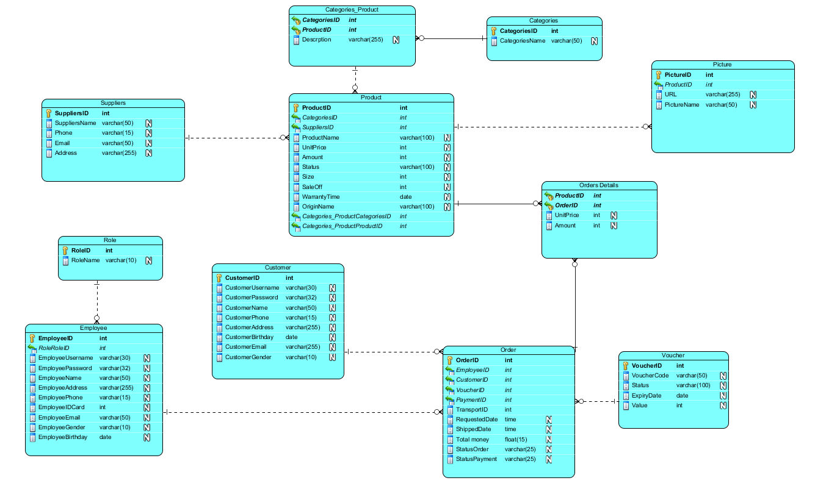

Figure. The partial data model for release 1.0 of the Shop Online Watches System.

# External Interface Requirements

## User Interfaces

* UI-1: UI-1: The homepage of the website displays shall conform to the *SEO Google*
* UI-2: The system shall provide a help link from each displayed webpage to explain how to use that page.
* UI-3: The webpages shall permit complete navigation and watches item selection by using the keyboard alone, in addition to using mouse and keyboard combinations.

## Software Interfaces

**SI-1: Producer system**

* SI-1.1: Staff will send information on defective products to the manufacturer through the interface.
* SI-1.2: Admin will probe the Producer system to update product prices.

**SI-2: Payment System**

* SI-2.1: Check transaction status.
* SI-2.2: View monthly report.

## Hardware Interfaces

No hardware interfaces have been identified.

## Communications Interfaces

* CI-1: The System shall send a text message (based on user account settings) to the Customer to confirm acceptance of an order, price.
* CI-2: The System shall send text messages (based on user account settings) to the Customer to report any problems or events with the product order.

# Quality Attributes

## Usability

* USE-1: All statistics can be viewed at the admin homepage in tabular format.

## Performance

* PER-1: The system can satisfy 100 users at the same time.
* PER-2: Loading page takes 3 seconds to display.
* PER-3: Hosting: Ram 2 GB, Storage: 50 GB, Backup Daily.
* PER-4: Client / Server Connection: 500KB / s.
* PER-5: Resize images 500x500 before loading them to the page.

## Security

* SEC-1: Only 1 role admin account can access the management page.
* SEC-2: User and employee passwords are hashed by MD5.
* SEC-3: Encrypted HTTPS protocol.

## Safety

* AVL-1: The system depends on the Hosting Provider if the maintenance provider will cause interruption.

## Install ability Requirements

* IA-1: The installation of the system for the user must be done by a partner Software developer or Customer System Administrator with at least 2 months of experience in C # and related libraries.
* IA-2: Or the plugin upgrade will not change data and structure data of the system.